CV
Hossam Amin Bayomi Mohamed
1) Personal data :
Name(Arabic) | حسام امين بيومي محمد
Name (English) | Hossam Amin Bayomi Mohamed
Department | Hepatology , Gastroenterology& Infectious Diseases
College | Benha faculty of medicine ,University of Benha , Egypt
Acadimic degree | M.D. (2000)
Current job | Professor of Hepatology, Gastroenterology& Infectious Diseases
Date of birth | 12 may 1965
Mobile | 01223923862
Home phone | 0133189334
Work phone | 0133257585
E-mail | Hossamameen965@gmail.com
Home address | Benha-Qalyubia-Egypt
Recent photo | 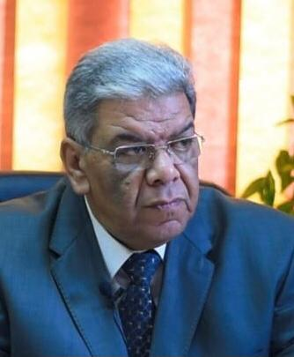

2) Education :
Institution | Degree obtained | Year
Zagazig University – Benha | M.B:B.CH | 1989
Zagazig University – Benha | Master of Tropical medicine | 1994
Zagazig University – Benha | MD of Tropical medicine | 2000

General specialty | Tropical medicine
Specific specialty | Hepatology , Gastroenterology& Infectious Diseases

Language skills/
Language | Reading | Speaking | Writing
Arabic | Excellent | Excellent | Excellent
English | Excellent | Excellent | Excellent

3) Membership of professional bodies (List) :

1- A member of Egyptian Society of Hepatology, Gasroenterology and Infectious diseases ( main branch)
2- A member of Egyptian Society of Hepatology, Gasroenterology and Infectious diseases ( Kalubia branch)

4) Areas of research
- Tropical diseases
- Hepatic diseases
- GIT disorders
- Infectious diseases
- Endoscopy

5) Positions:
 | Date  From – to | Organization | Country | Position | Role
1 | 2011- till Now | Faculty of Medicine- Benha Univ | Egypt | professor | Teaching,research,
2 | 2006- 2011 | Faculty of Medicine- Benha Univ | Egypt | Ass.professor | Teaching,research,
3 | 2001-2006 | Faculty 0f Medicine- Benha Univ | Egypt | Lecturer | Teaching,Research
4 | 1995-2000 | Faculty of Medicine- Benha Univ | Egypt | Ass.lecture | Teaching research
5 | 1991-1994 | Faculty of Medicine- Benha Univ | Egypt | Resident | Teaching research

6) Supervision on many PhD/MSc researchs
7) Consulting Experience:
- Diagnostic and therapeutic upper and lower GIT endoscopies
-ERCP

8) PROFESSIONAL TECHNIQUES AND AREA OF EXPERTISE:
- Diagnostic and therapeutic upper and lower GIT endoscopies
- ERCP

9) Many publications in Hepatology , Gastroenterology& Infectious Diseases

